**VacationPy – Maps**

1. Heat Map

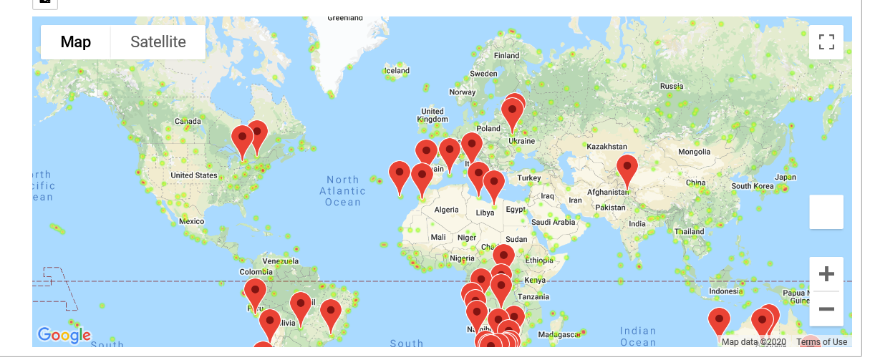

1. Hotel Map with Markers

